NATIONAL INSTITUTE OF TECHNOLOGY
TIRUCHIRAPPALLI


Department of Computer Applications

Case Tools Lab

Software Requirement Specification
On
NITT EVENTS MANAGEMENT SYSTEM

Submitted By

Dharmendra Kumar Gupta - 205112078

Under the guidance of

Dr. B. Janet

TABLE OF CONTENTS

CONTENTS Page no.

- PROBLEM STATEMENT 1
- SOFTWARE REQUIREMENT SPECIFICATION 2-10
- PROCESS MODEL 11-13
- ENTITY RELATIONSHIP DIAGRAMS 14
- DATA FLOW DIAGRAMS 15-17
- OBJECT MODEL DIAGRAM 19-20
- SEQUENCE DIAGRAM 21-22
- USE CASE DIAGRAM 23
- STATECHARTS 25-31
- TESTING 37-39
- LIMITATIONS 40
- ADVANTAGES 40
- FUTURE SCOPE 40
- BIBILOGRAPHY 41

PROBLEM STATEMENT

Problem of Existing System
There are many events organized by students in NITT in every year. There are some difficulty comes during that time for booking the place (Halls). Some problems related to Hall booking are as follows:-
- Two or more events occur in the same days.
- No certain place is available for the specific events.
- Two or more event’s organizer wants the same place for organizing there events.
- Choosing which place or ground is most convenient for a certain event.
- We can also do this work on paper but this will be a tedious task.
Remove these problems by using this project
This project is aimed at developing an Event Management system that is of importance to a NITT college. The NITT Events Management System is an application that can be accessed throughout the college on Delta server.
The proposed system can be used for booking the hall rooms which are available in NITT. This project will be able to find out which hall is recently vacant on a particular date and if it is vacant on that day then book that day for Event. This project is also a user friendly application.
This system will reduce a lot of paper work and hence load on administrative staff. Machines perform all the calculation therefore the chances of error are nil. Also deletion, addition and updating can be performed easily. Another major benefit is that unauthorized access is prevented due to ID verification.

SOFTWARE REQUIREMENT SPECIFICATION

- INTRODUCTION

  - Purpose

The origin of most software systems is in the need of a client, who either wants to automate the existing manual system or desires a new software system. The software system is itself created by the developer. Finally, the end user will use the completed system. Thus, there are three major parties interested in a new system: the client, the user, and the developer. Somehow the requirements for the system that will satisfy the needs of the clients and the concerns of the users have to be communicated to the developer. The problem is that the client doesn’t usually design the software or the software development process and the developer does not understand the client’s problem and the application area. This causes a communication gap between the parties involved in the development of the project.
The basic purpose of Software Requirement Specification (SRS) is to bridge this communication gap. SRS is the medium through which the client’s and the user’s needs are accurately specified; indeed SRS forms the basis of software development.
Another important purpose of developing an SRS is helping the clients understanding their own needs. An SRS establishes the basis for agreement between the client and the supplier on what the software product will do.
An SRS provides a reference for validation of the final product.

A high quality SRS is a prerequisite to high quality software and it also reduces the development cost.

The objective is to provide users with software with which they can interact and can get most of their initial work done and also for getting detailed information about judgment made on a case.

  - Scope

The proposed system can be used to automate the workflow of leave applications and their approvals. The periodic crediting of leave is also automated. There are features like cancellation of leave, automatic approval of leave, report generators etc. in this system.

  - Definition, acronym, abbreviation

Acronyms

- DFD Data Flow Diagram
- ERD Entity Relationship Diagram
- SRS Software Requirement Specification
- ID no. Identification Number

Definitions

- Applicant The person who applies for the leave.
- Approver The person who approves/rejects requests.
- Administrator Person handling all the work.

  - Reference

- Software Engineering, A Practitioners approach Edition 5
by Roger S. Pressman
McGraw Hill Publications

  - Overview

The software is easy to use and does not require the user to have detailed knowledge about computers. Thus the project would help the users to carry out all the leave request work in the college without any chaos which would result in users’ satisfaction thereby obtaining its basic goal.

The Administrator maintains the records of the leave applications.
.

- Overall Description

  - Product perspective

- The digitalization of the system will reduce a lot of paperwork and hence the load on the administrative staff.

- The data can easily be retrieved and any required addition, deletion or updating can be performed.

- The system provides for user-ID validation, hence unauthorized access is prevented.

    - User Interface

- A login Screen (For verifying username and password)
- Leave application form

    - Hardware Interface

- Mouse
- Keyboard

    - Software Interface

- Any window based operating system are primary requirements for software development. The system must connect to the intranet therefore LAN network is necessary.

    - Communication Interface

Local Area Network for inter-connecting the systems of college.

    - Memory Constraints

It specifies the requirements like memory restrictions, cache size, the processor, RAM size etc... those are required for the software to run.

Minimum Requirements

- Processor Pentium III
- Hard disk drive 40 GB
- RAM 256 MB

Preferred Requirements
- Processor Pentium IV
- Hard disk drive 80 GB
- RAM 512 MB

  - Product Functions

The main functions of the Software-

Users: The Online leave management system is useful to request for leaves online. Its target user group consists of students, staff etc.
Purpose: The Purpose of the project is to maintain the information regarding the leaves request by a applicant in a year.
Maintenance of database: The software allows easy updating items. New items can be added in the database; old items can be modified or removed from it.

  - User Characteristics

- EDUCATIONAL LEVEL

At least user of the system should be comfortable with English language.

- TECHNICAL EXPERTISE

User should be comfortable using general purpose applications on the computer system.

  - Constraints

The system will run under windows XP or higher platforms of operating system.

  - Assumptions

Administrator will be having a valid account type, user name an password to access the software.

The software needs students and staff members to have complete knowledge of Online leave management system.

- Specific Requirements

3.1 External Interface Requirements

The details of various screen formats are documented. Online help is also available for admin as well as users including applicant and approver.

3.2 Performance Requirements

There are certain performance requirements that the software tries to meet. These are:

      - User Friendliness - The software terms should be self explanatory and use –friendly. This makes the task of the user much easier.

      - Ease To Maintain - Software should not have high maintenance cost. Design should be simple and concise so that problems regarding maintenance are least expected.

      - Error Free - Software should be developed in such a manner that it is most accurate. Scope for error within the software should be minimized.

      - Less Time Consuming - The software should be developed and designed to make the task of the users easier and quicker. It is obviously more time consuming to do a task manually than by a machine.

  - Other Requirements

Software should satisfy following requirements as well:-
      - Security
      - Portability
      - Correctness
      - Efficiency
      - Flexibility
      - Testability
      - Reusability

- Design constraints

There are a number of factors in the client’s environment that may restrict the choices of a designer. Such factors include standards that must be followed, resource limits, operating environment, reliability and security requirements, and policies that may have an impact on the design of the system. An SRS (Software Requirements analysis and Specification) should identify and specify all such constraints.

Standard Compliance: This specifies the requirements for the standards the system must follow. The standards may include the report format and accounting procedures.

Hardware Limitations: The software may have to operate on some existing or predetermined hardware, thus imposing restrictions on the design. Hardware limitations can include the type of machines to be used, operating system available on the system, languages supported, and limits on primary & secondary storage.

Hardware limitations of this software are: -
      - Software runs on Pentium level computers with at least 256 MB of memory.
      - The system should have Windows 95 or its higher version.
- Security

Security requirements are particularly significant in database systems. They place restrictions on the use of certain commands, control access to data, provide different kinds of access requirements for different people, require the use of passwords and cryptography techniques and maintain a log of activities in the system.

The proposed system uses username and user ID verification to access details and data of applicants.

SYSTEM PROCESS MODEL
To solve a particular problem a software engineer or a team of software engineers must incorporate a development strategy than encompasses the process, methods and tools. This strategy is often referred to as a process model or a “SOFTWARE ENGINEERING PARADIGM”. The use of a particular process model or software paradigm is based on the nature of the application.

A software life cycle is the series of identifiable stages that a software product undergoes during its lifetime. A software life cycle model is a descriptive and diagrammatic representation of the software life cycle. A life cycle model represents all the activities required to make a software product transit through its life cycle phases. It also captures the order in which these activities are to be undertaken. A life cycle model maps the different activities performed on a software product from its inception to retirement.

Different life cycle models may map the basic development activities to phases in different ways. Thus, no matter which life cycle model is followed, the basic activities are included in all life cycle models though the activities may be carried out in different orders in different life cycle models. During any life cycle phases, more than one activity may also be carried out.
A process covers all the activities beginning from product inception through delivery and retirement. It addresses the broader issue of reuse, documentation, testing, parallel work carried out by team members and coordination with the customer.

A software application may be for an application of real time system, a database system, an operating system or a web based application. Primary advantage of using a life cycle model is that it encourages development of software in a systematic & disciplined manner.

Using a process model gives a good understanding of project to all the team members i.e. what to do & when? It prevents misinterpretations, helps in identifying inconsistencies, redundancies.

Some of them are given below: -

- Waterfall model

- Prototype model

- Iterative enhancement model

- Spiral model

- Rapid action development model (RAD Model)

- Fourth generation technique (4GT)

The following points states the need of a particular software paradigm for development of a software.

- To improve the quality of software.

- To increase the productivity of software development.

- To development of software on time.

- To produce a reliable software.

- To develop the software with in cost estimates.

Thus the above said discussion states that a software paradigm is very necessary to develop software.
So in our project we are following the Iterative model for the development of our project.

Iterative Enhancement Model: - This model provides the benefit of both Prototype and Waterfall model. The basic idea is that the software should be developed in increments, each increment adding some functional capability to the system until the full system implemented.

Requirement analysis and specification
Design
Coding and unit testing
Integrating and system testing
Maintenance
Feasibility study

ITERATIVE WATERFALL MODEL

NITT EVENTS MANAGEMENT SYSTEM
Vacant
ER-DIAGRAM

Hall Name
Date
Information

Information

Want to book Hall
HALL DETAILS
EVENTS DETAILS
N
Name

Address

M
M
Check Date

N N

Booking
Event name
ALLOTMENT DETAILS
Date
Duration

Date
Hall Name

NITT EVENTS MANAGEMENT SYSTEM

Data Flow Diagram

USER
NITT Events Management System
USER

Logs to

Booking Hall in NITT.

Display the alloted events

Hall Informations

Display the vacant hall on a date

About

Fig: 0 Level DFD Enclosed overall system

USER
Events Management System
Logs to
DATA REPOSITORY
USER
Report
0 Level DFD

USER
1.1
Hall
Record
Entry

1.2
Hall
Allotment
1.3 Hall
Information
HALL

HALL
HALL
Logs to
USER
Conformation Message
1st Level DFD

NITT EVENTS MANAGEMENTS SYSTEM
Report on Configuration DefaultConfig
Packages
Events
Language: C++
Object Model Diagrams:

NITT EVENTS MANAGEMENT SYSTEM
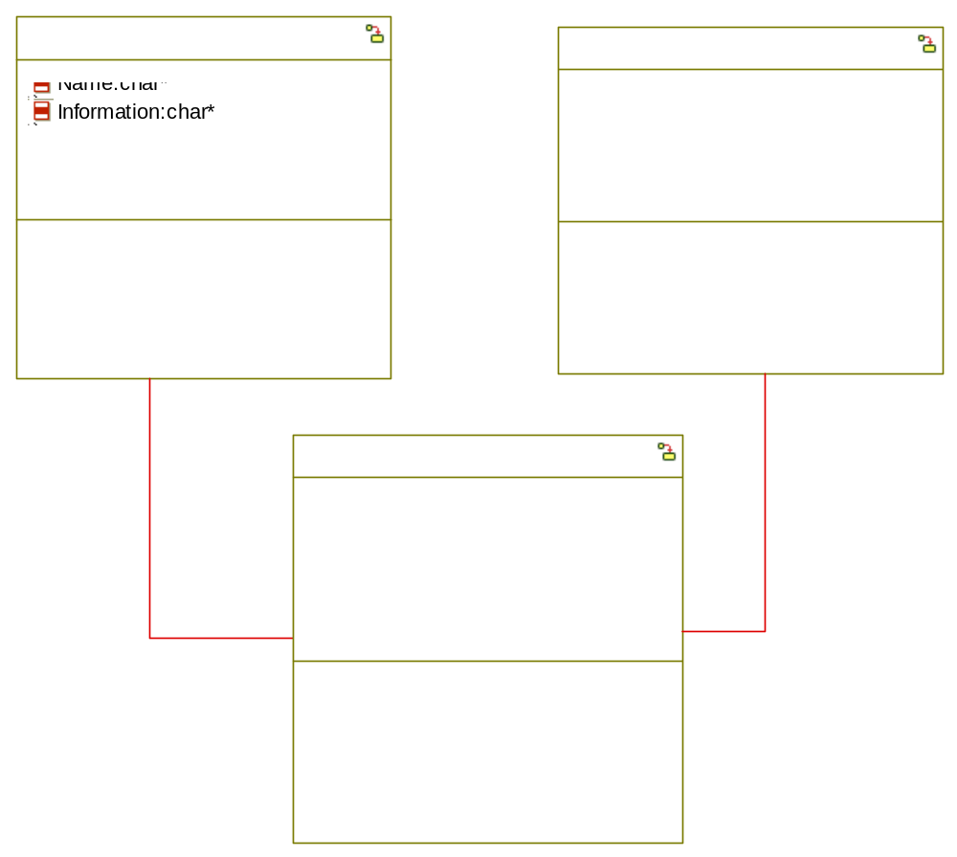
Overridden Properties
Subjects:
Format
Metaclasses:
Class
Properties:
Line.LineWidth: 1
Font.FontColor: 0,0,0
Font.Font: Arial
Fill.FillColor: 255,255,255
Line.LineStyle: 0
DefaultSize: 0,34,84,148
Font.Size: 10
Line.LineColor: 121,122,0
Association
Properties:
Line.LineWidth: 1
Font.FontColor: 0,0,128
Font.Font: Arial
Font.Size: 10
Line.LineColor: 221,0,0
Object
Properties:
Font.Underline@Child.NameCompartment@Name: 1
Line.LineWidth: 1
Font.FontColor: 0,0,0
Font.Font: Arial
Fill.FillColor: 255,255,255
Line.LineStyle: 0
DefaultSize: 0,34,84,148
Font.Size: 10
Line.LineColor: 121,122,0

Build
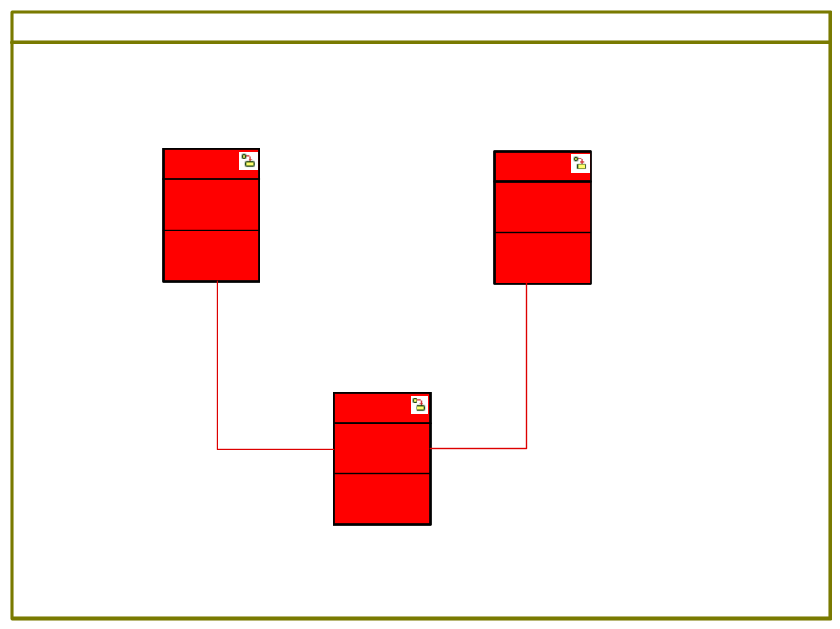
Overridden Properties
Subjects:
Format
Metaclasses:
Class
Properties:
Line.LineWidth: 1
Font.FontColor: 0,0,0
Font.Font: Arial
Fill.FillColor: 255,255,255
Line.LineStyle: 0
DefaultSize: 0,34,84,148
Font.Size: 10
Line.LineColor: 121,122,0
Association
Properties:
Line.LineWidth: 1
Font.FontColor: 0,0,128
Font.Font: Arial
Font.Size: 10
Line.LineColor: 221,0,0
Sequence Diagrams:

EventManagementSystem
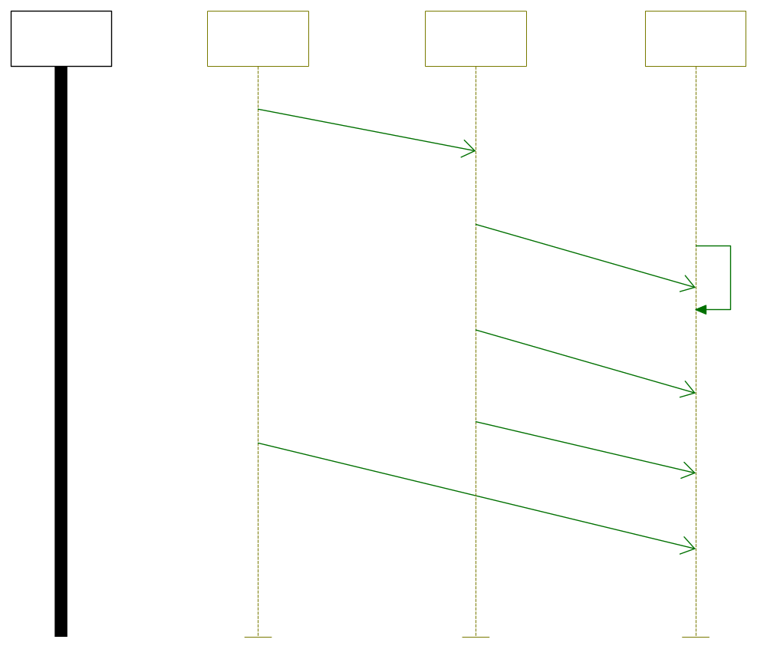
Overridden Properties
Subjects:
Format
Metaclasses:
InstanceLine
Properties:
Line.LineWidth: 0
Font.FontColor: 0,0,0
Font.Font: Arial
Fill.FillColor: 255,255,255
DefaultSize: 0,0,96,437
Font.Size: 10
Line.LineColor: 121,122,0
Message
Properties:
Line.LineWidth: 1
Font.FontColor: 0,0,128
Font.Font: Arial
Font.Size: 10
Line.LineColor: 0,112,0
EnvironmentLine
Properties:
Line.LineWidth: 1
Font.FontColor: 0,0,0
Font.Font: Arial
Fill.FillColor: 255,255,255
DefaultSize: 0,0,96,437
Font.Size: 10
Line.LineColor: 0,0,0
Use Case Diagrams:

NITT EVENTS
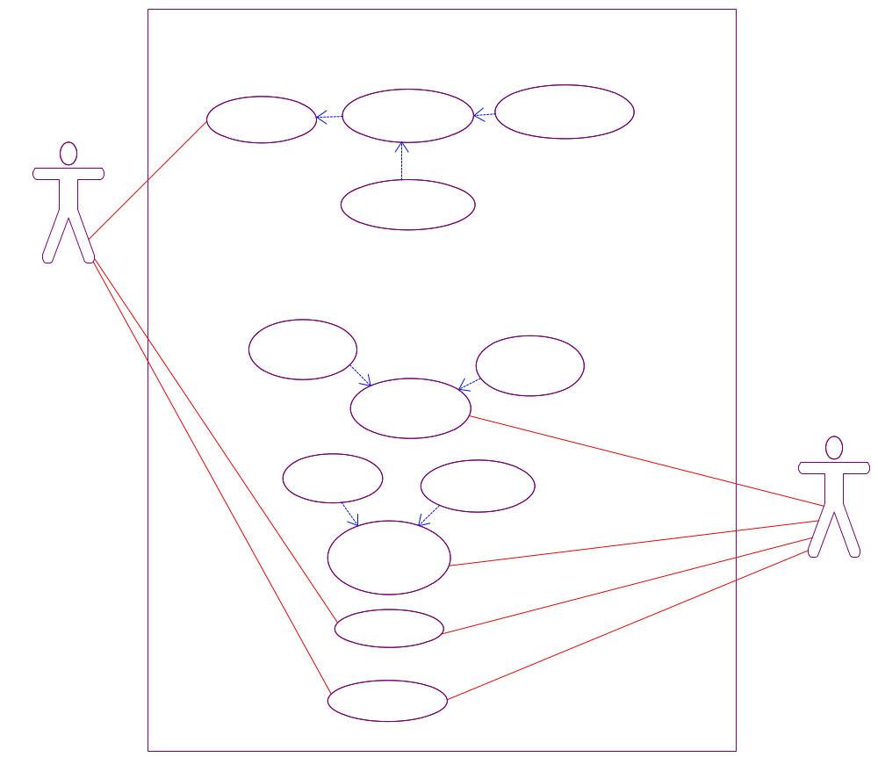
Overridden Properties
Subjects:
Format
Metaclasses:
Actor
Properties:
Line.LineWidth: 1
Font.FontColor: 0,0,128
Font.Font: Arial
Fill.FillColor: 255,255,255
DefaultSize: 0,26,84,168
Font.Size: 10
Line.LineColor: 111,0,107
UseCase
Properties:
Line.LineWidth: 1
Font.FontColor: 0,0,0
Font.Font: Arial
Fill.FillColor: 255,255,255
DefaultSize: 0,21,129,92
Font.Size: 10
Line.LineColor: 111,0,107
System_Border
Properties:
Line.LineWidth: 1
Font.FontColor: 0,0,0
Font.Font: Arial
Fill.FillColor: 255,255,255
DefaultSize: 0,0,228,240
Font.Size: 10
Line.LineColor: 111,0,107
Association
Properties:
Line.LineWidth: 1
Font.FontColor: 0,0,128
Font.Font: Arial
Font.Size: 10
Line.LineColor: 221,0,0
Depends
Properties:
Line.LineWidth: 0
Font.FontColor: 0,0,128
Font.Font: Arial
Line.LineStyle: 1
Font.Size: 10
Line.LineColor: 0,16,230
Events:

evClose

evOpen

s

tmAdd
Globals:
Objects:
Event_Object
Implicit, Multiplicity of 1
Classes:

Booking
Association Ends:
itsEvent
Association with Event, Multiplicity of 1, Bi-directional, Navigable
itsEvent_1
Association with Event, Multiplicity of 1, Bi-directional, Navigable
itsHall
Association with Hall, Multiplicity of 1, Bi-directional, Navigable
itsHall_1
Association with Hall, Multiplicity of 1, Bi-directional, Navigable
Operations:
Allot
Primitive-operation , Public, Return type is void
Check_Allotment
Primitive-operation , Public, Return type is void
evClose
Reception
evOpen
Reception
Attributes:
Date
Type of char*, Public, Multiplicity of 1
Event
Type of EVENT, Public, Multiplicity of 1
Hall
Type of HALL, Public, Multiplicity of 1
Time
Type of char*, Public, Multiplicity of 1
Statechart
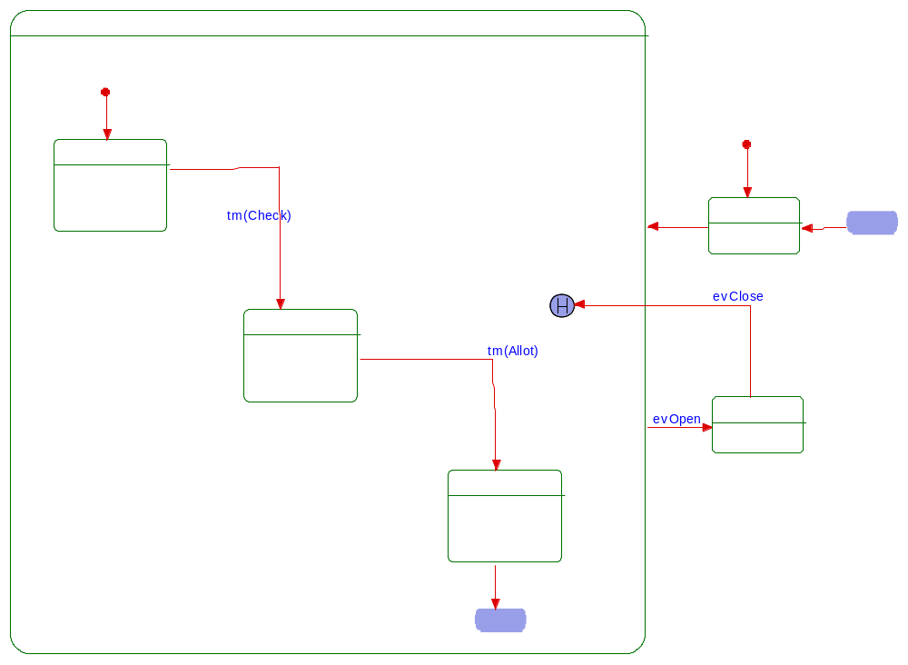
Overridden Properties
Subjects:
Format
Metaclasses:
DefaultTransition
Properties:
Line.LineWidth: 1
Font.FontColor: 0,0,255
Font.Font: Arial
Font.Size: 10
Line.LineColor: 221,0,0
DiagramConnector
Properties:
Line.LineWidth: 1
Font.FontColor: 0,0,0
Font.Font: Arial
Fill.FillColor: 152,158,231
DefaultSize: 0,0,55,24
Font.Size: 10
Line.LineColor: 0,0,0
Transition
Properties:
Line.LineWidth: 1
Font.FontColor: 0,0,255
Font.Font: Arial
Font.Size: 10
Line.LineColor: 221,0,0
HistoryConnector
Properties:
Line.LineWidth: 1
Font.FontColor: 0,0,0
Font.Font: Arial
Fill.FillColor: 152,158,231
DefaultSize: 0,0,25,23
Font.Size: 10
Line.LineColor: 0,0,0
DanglingTransition
Properties:
Line.LineWidth: 2
Line.LineColor: 0,0,0
State
Properties:
Line.LineWidth: 1
Font.FontColor: 0,0,0
Font.Font: Arial
Fill.FillColor: 255,255,255
Line.LineStyle: 0
DefaultSize: 0,0,96,60
Font.Size: 10
Line.LineColor: 0,112,0
ROOT
Or-state
Substates:
Off
Open
Running
Default Transition
Target:
Off
Off
Or-state
Out Transition
Target:
Running
Open
Or-state
Out Transition
evClose
Target:
History Connector
Running
Or-state
Substates:
Allot
Booking
Check
Out Transition
evOpen
Target:
Open
Default Transition
Target:
Booking
Allot
Or-state
Out Transition
Target:
Done
Booking
Or-state
Out Transition
tm(Check)
Target:
Check
Check
Or-state
Out Transition
tm(Allot)
Target:
Allot
Done
Diagram Connector
Out Transition
Target:
Off
Done
Diagram Connector

EVENT
Objects:
HALL
Implicit, Multiplicity of 1
object_1
Implicit, Multiplicity of 1

Event
Association Ends:
itsBooking
Association with Booking, Multiplicity of 1, Bi-directional, Navigable
itsBooking_1
Association with Booking, Multiplicity of 1, Bi-directional, Navigable
Operations:
Check_Date
Primitive-operation , Public, Return type is void
Display
Primitive-operation , Public, Return type is void
evClose
Reception
evOpen
Reception
Input
Primitive-operation , Public, Return type is void
s
Reception
tmAdd
Reception
Attributes:
Information
Type of char*, Public, Multiplicity of 1
Name
Type of char*, Public, Multiplicity of 1
Statechart
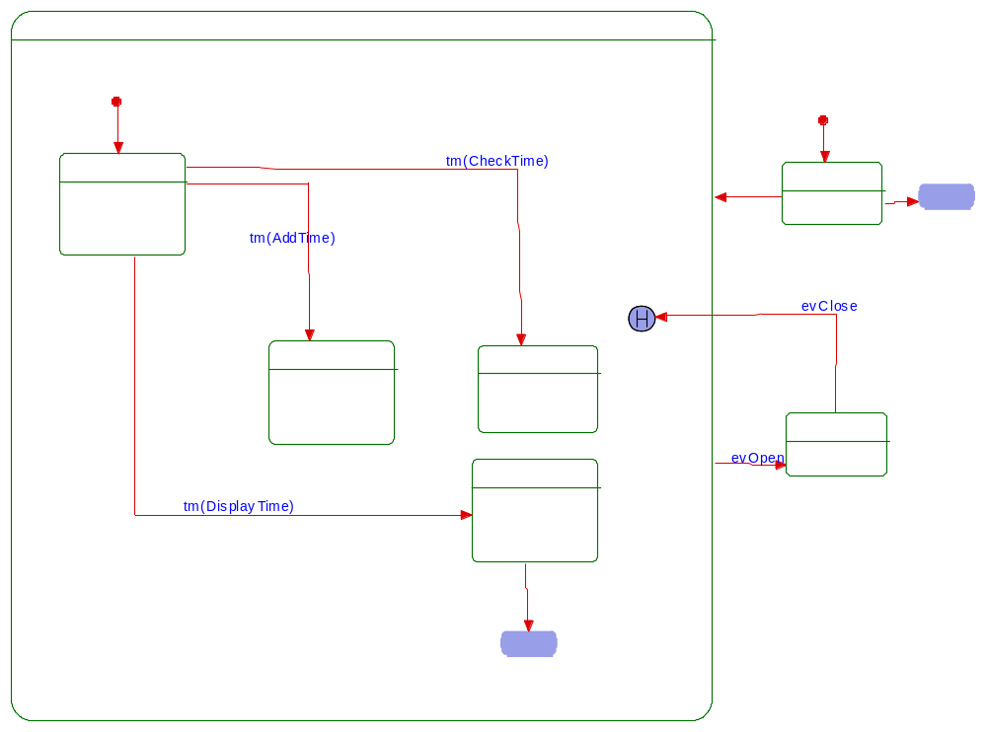
Overridden Properties
Subjects:
Format
Metaclasses:
DiagramConnector
Properties:
Line.LineWidth: 1
Font.FontColor: 0,0,0
Font.Font: Arial
Fill.FillColor: 152,158,231
DefaultSize: 0,0,55,24
Font.Size: 10
Line.LineColor: 0,0,0
HistoryConnector
Properties:
Line.LineWidth: 1
Font.FontColor: 0,0,0
Font.Font: Arial
Fill.FillColor: 152,158,231
DefaultSize: 0,0,25,23
Font.Size: 10
Line.LineColor: 0,0,0
DanglingTransition
Properties:
Line.LineWidth: 2
Line.LineColor: 0,0,0
State
Properties:
Line.LineWidth: 1
Font.FontColor: 0,0,0
Font.Font: Arial
Fill.FillColor: 255,255,255
Line.LineStyle: 0
DefaultSize: 0,0,96,60
Font.Size: 10
Line.LineColor: 0,112,0
ROOT
Or-state
Substates:
Off
Open
Running
Default Transition
Target:
Off
Off
Or-state
Out Transition
Target:
Running
Out Transition
Target:
Done
Open
Or-state
Out Transition
evClose
Target:
History Connector
Running
Or-state
Substates:
Adding
Checking
Displaying
Events
Out Transition
evOpen
Target:
Open
Default Transition
Target:
Events
Adding
Or-state
Checking
Or-state
Displaying
Or-state
Out Transition
Target:
Done
Events
Or-state
Out Transition
tm(AddTime)
Target:
Adding
Out Transition
tm(DisplayTime)
Target:
Displaying
Out Transition
tm(CheckTime)
Target:
Checking
Done
Diagram Connector
Done
Diagram Connector

Events
Objects:
jw
Implicit, Multiplicity of 1
object_0
Implicit, Multiplicity of 1

EVENTS
Objects:
Event_Name
Implicit, Multiplicity of 1
Information
Implicit, Multiplicity of 1

EventsManagement

Hall
Association Ends:
itsBooking
Association with Booking, Multiplicity of 1, Bi-directional, Navigable
itsBooking_1
Association with Booking, Multiplicity of 1, Bi-directional, Navigable
Operations:
Display
Primitive-operation , Public, Return type is void
Input
Primitive-operation , Public, Return type is void
Attributes:
Information
Type of char*, Public, Multiplicity of 1
Name
Type of char*, Public, Multiplicity of 1
Statechart
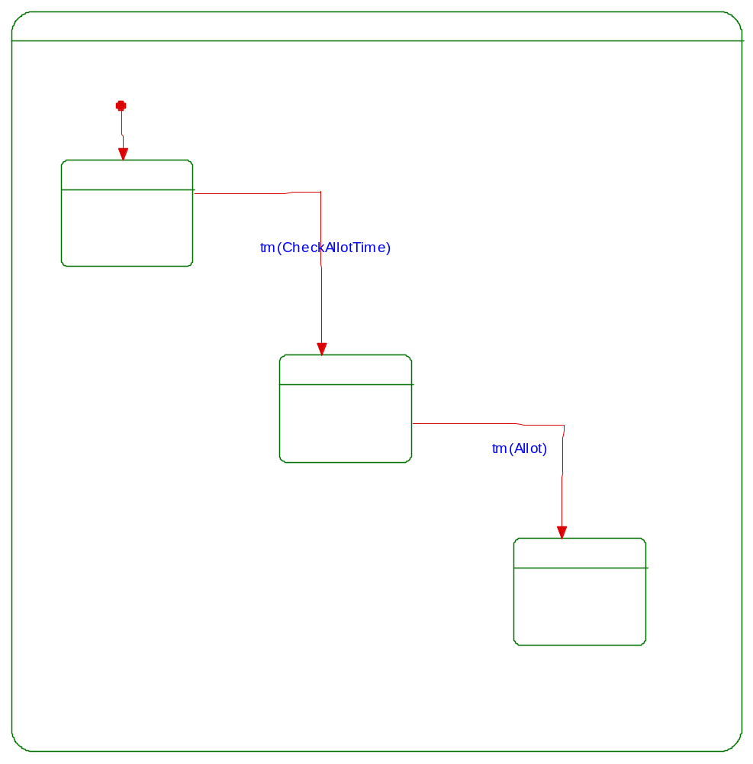
Overridden Properties
Subjects:
Format
Metaclasses:
DefaultTransition
Properties:
Line.LineWidth: 1
Font.FontColor: 0,0,255
Font.Font: Arial
Font.Size: 10
Line.LineColor: 221,0,0
Transition
Properties:
Line.LineWidth: 1
Font.FontColor: 0,0,255
Font.Font: Arial
Font.Size: 10
Line.LineColor: 221,0,0
DanglingTransition
Properties:
Line.LineWidth: 2
Line.LineColor: 0,0,0
State
Properties:
Line.LineWidth: 1
Font.FontColor: 0,0,0
Font.Font: Arial
Fill.FillColor: 255,255,255
Line.LineStyle: 0
DefaultSize: 0,0,96,60
Font.Size: 10
Line.LineColor: 0,112,0
ROOT
Or-state
Substates:
Running
Running
Or-state
Substates:
Allot
CheckAllotement
Hall
Default Transition
Target:
Hall
Allot
Or-state
CheckAllotement
Or-state
Out Transition
tm(Allot)
Target:
Allot
Hall
Or-state
Out Transition
tm(CheckAllotTime)
Target:
CheckAllotement

HALL
Objects:
Hall_Information
Implicit, Multiplicity of 1
Hall_Name
Implicit, Multiplicity of 1
Actors:

Events Administrator
Association Ends:
itsLocal Events
Association with Local Events, Multiplicity of 1, Bi-directional, Navigable
itsManage Events
Association with Manage Events, Multiplicity of 1, Bi-directional, Navigable
itsView Events
Association with View Events, Multiplicity of 1, Bi-directional, Navigable

Participants
Association Ends:
itsLocal Events
Association with Local Events, Multiplicity of 1, Bi-directional, Navigable
itsManage Participation in Events
Association with Manage Participation in Events, Multiplicity of 1, Bi-directional, Navigable
itsReceive Events Communications
Association with Receive Events Communications, Multiplicity of 1, Bi-directional, Navigable
itsView Events
Association with View Events, Multiplicity of 1, Bi-directional, Navigable
Use Cases:

Gets Conformation Email

Gets Events Invite

Local Events
Association Ends:
itsEvents Administrator
itsParticipants

Manage Events
Association Ends:
itsEvents Administrator

Manage Participant

Manage Participation in Events
Association Ends:
itsParticipants

Receive Events Communications
Association Ends:
itsParticipants

Resister for Events

Sends Invite Email

Sets Registration Rule

Un-Resister for Events

usecase_2

View Events
Association Ends:
itsEvents Administrator
itsParticipants
Object Model Diagrams

Model1
Components
DefaultComponent
Language: C++
Component Settings:
Build type: Executable
Configurations:

DefaultConfig
Scope type: Explicit
Instrumentation type: None
Time-model type: Real-time
Statechart generation type: Flat
Files and Folders:

TESTING
INTRODUCTION
Software Testing is the process of executing a program or system with the intent of finding errors. Software is not unlike other physical processes where inputs are received and outputs are produced. Where software differs is in the manner in which it fails. Most physical systems fail in a fixed (and reasonably small) set of ways. By contrast, software can fail in many bizarre ways. Detecting all of the different failure modes for software is generally infeasible.
It is a critical element of software quality assurance and represents the ultimate review of specification, design, and code generation. Once source code has been generated, software must be tested to uncover as many tests as possible before delivery to the customer.

These techniques provide systematic guidance for designing tests that exercise the internal logic of software components and exercise the input and output domains of the program to uncover errors in program function, behavior, and performance. Unlike most physical systems, most of the defects in software are design errors, not manufacturing defects. Software does not suffer from corrosion, wear-and-tear generally it will not change until upgrades, or until obsolescence. So once the software is shipped, the design defects or bugs will be buried in and remain latent until activation.
TWO WAYS OF TESTING

1. BLACK BOX THEORY

Also called behavioral testing, focuses on the functional requirements to the software. That is, black box testing enables the software engineer to derive sets of inputs conditions that will fully exercise to white-box techniques. Alludes to tests that are conducted at the software interface. Although they are designed to uncover errors, black box tests are used to demonstrate that software functions are operational, that input is properly accepted and output is correctly produced, and the integrity of external information is maintained. A black box test examines some fundamental aspects of a system with little regard for internal logical structure of the software.

2. WHITE BOX THEORY
Sometimes called glass-box testing, is a test case design that uses the control structure of the procedural design to derive test cases. It is predicated on close examination of procedural details. Logical paths through the software are tested by providing test cases that exercise specific sets of conditions and/or loops. The “status of the program” may be examined at various points to determine if the expected or asserted status corresponds to the actual status.

software testing strategy

there are four types of software testing strategy:-

- Unit testing: begins at the vortex of the spiral and concentrates on each unit of the software as implemented in source code.
- Integration testing: focus is on design and the construction of the software architecture.
- Validation testing: where requirements established as part of software requirements are validated against the software has been constructed.
- System testing: where the software and other system elements are tested as a whole.

LIMITATIONS OF THE SOFTWARE
- Extensive help is not provided.
- Not support in the OS lower than windows XP.

ADVANTAGES PROPOSED SYSTEM
There are many advantages of utilizing a web based leave tracking system:
- Eliminates paper based leave application forms
- Leave applications can be submitted online
- Leave applications can be approved online
- Both the leave applicant as well as the approver can view the remaining leave days as well as historical leave applications in case of a student or a staff.

FUTURE SCOPE

In present all leave applications and their approvals have been computerized through centralized software. Later on, we can add the features to maintain all monthly attendance using this software.

BIBLIOGRAPHY

1. INTERNET RESOURCES
- www.scribd.com
- www.files32.com

2. BOOKS
- SOFTWARE ENGINEERING - SHALINI PURI
- SOFTWARE ENGINEERING - PRESSMAN

